BILKENT UNIVERSITY


MECHANICAL ENGINEERING DEPARTMENT

ME 232 –MECHANICS AND MATERIALS II
EXPERIMENT REPORT

Tensile Test
Ahmet Nuri Kirişci
22003024 Section-1
Group: Day 2 Group 1

Submitted: 21.05.2023

Specimen 1 Metal:
- All data plotted on the same figure:
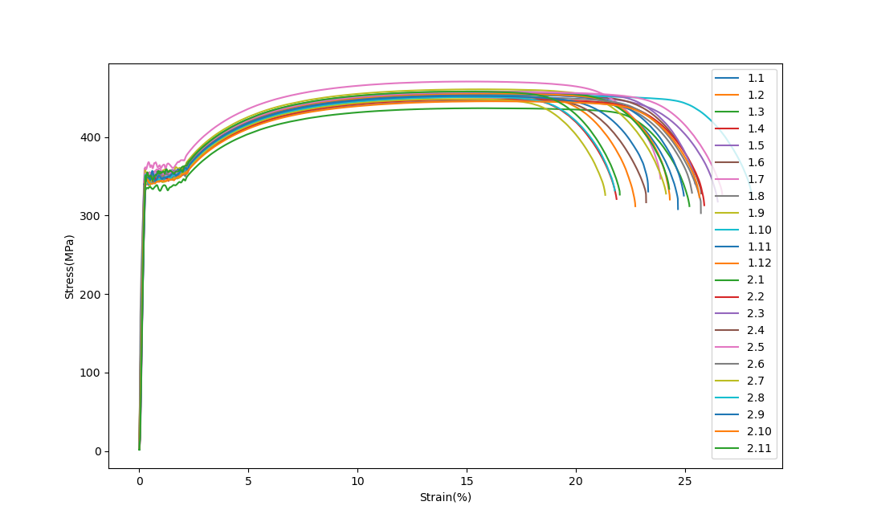
Comment on the difference:
Differences between the graphs occur due to errors in the measurement process. The most important reason for the difference is that specimens used in the measurements are different from each other due to their manufacturing process and imperfections within their microstructure. Another reason is the placement of the specimen between the clamps of the tensile test machine. For a correct measurement, the specimen must be placed perfectly vertically. Also the test conditions such as temperature, rate of pull, etc... should affect the results.

- Mean values for Young’s Modulus (E), 0.2% offset yield strength (𝜎₀), and ultimate tensile strength (𝜎_{u}).

Mean Young’s Modulus (E): 185.16 GPa
For the calculation of the young modulus, with the help of the Python code in the appendix two points(the first point with a stress value bigger than 150 for the upper point, and the second point with a stress value bigger than 50) has chosen from the linear region on the graphs for calculation. “E” is found by calculations of the slope through these two points.

Mean 0.2% Offset Yield Strength (𝜎₀): 346.54 MPa
For the calculation, in Excel, an 0.2% offset line is drawn on the stress-strain graph, and the interception is located from the graph. As in the example:

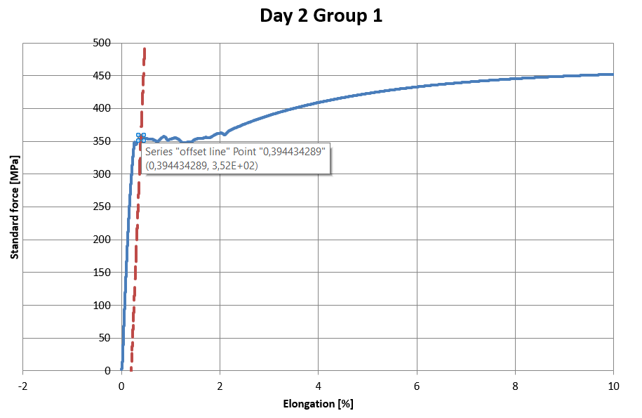

0.2% Offset Yield Strength (𝜎₀): 352 MPa

Mean for Ultimate Tensile Strength (𝜎_{u}): 453.37 MPa
Since the ultimate tensile strength is the highest stress value reached during the measurement, from the all data gathered maximum stress value is determined for each group and the mean is calculated.

DAY 2 GROUP 1 DATA

E = 180.99 Gpa Mean E: 185.16 GPa
𝜎₀ = 352 Mpa Mean 𝜎₀: 346.54 MPa
𝜎_{u} = 458.06 Mpa Mean 𝜎_{u}: 453.37 MPa

When the calculated values for Day2-Group1 compared with the calculated mean values for all groups, Young’s Modulus differs from the mean by 2%, Yield stress by 1.6%, and Ultimate stress by 1%. All three quantities deviate from the mean in an acceptable range. While Young’s Modulus has the highest deviation, Ultimate stress is the least deviating.

- Dependence of the Yield Strength on the Amount of offset:

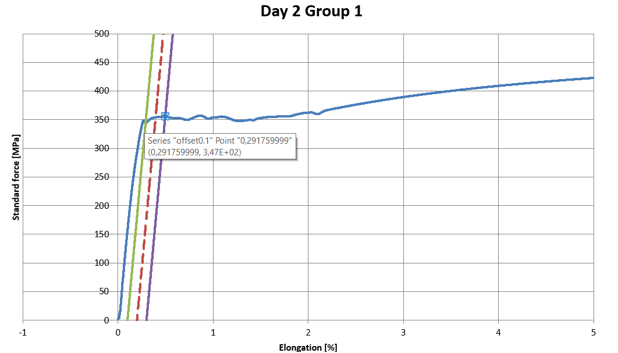

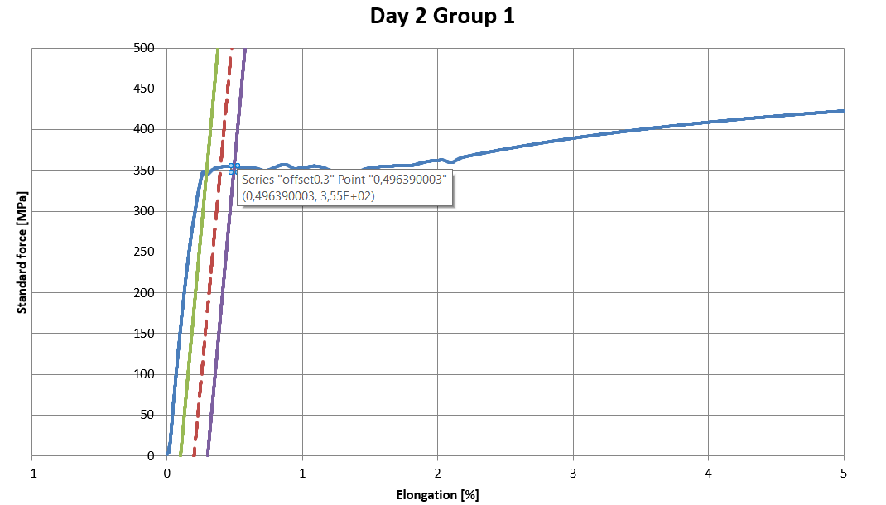

Yield Stress values for 0.1%, 0.2%, and 0.3% are determined as 347, 352, and 355 MPa respectively. This outcome is understandable since the offset values chosen for calculations correspond to a region where the graph increases.

- True vs Engineering

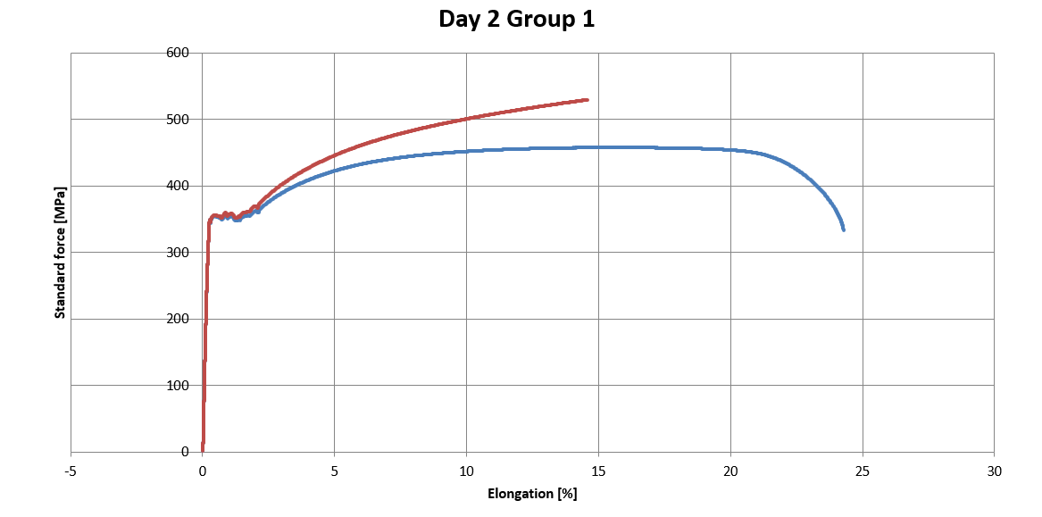
- Lüders Bands
Lüders Bands are the plastically deformed slip lines by a 45º angle. Lüders Bands occur between the elastic and plastic regions, where the stress-strain graph fluctuates around the same stress value at the onset of yielding. Especially the low-carbon steels in the tensile test present such behavior, since the carbon atoms prevent the slide of the slip systems for an increasing strain, stress value remains almost the same but increases up and down. This phenomena makes harder to estimate where the yielding occurs, and plastic deformation starts.

Specimen 2 Polymer:
- All data plot
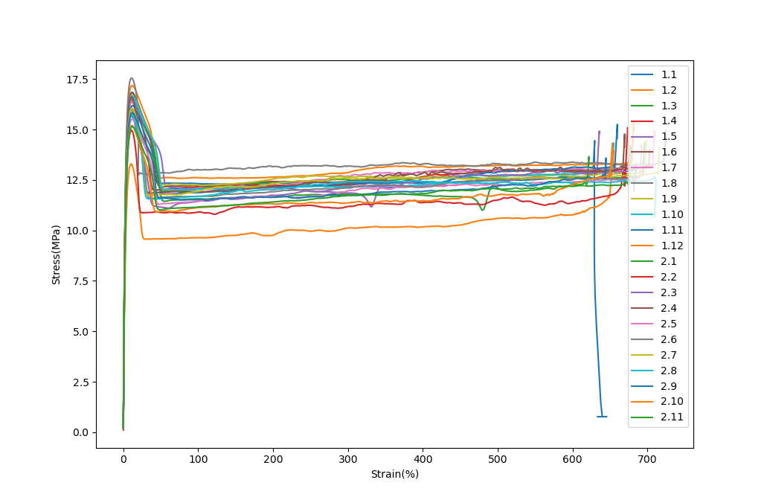

Mean for Ultimate Tensile Strength (𝜎_{u}): 16.11 MPa
Ultimate Tensile Strenght (DAY 2 GROUP 1 DATA) (𝜎_{u}): 15.81 MPa
When the two values are compared, it is observed that the calculated Ultimate Stress for the day2-group1 differs from the calculated mean by 1.9%, which is acceptable. Such deviation could occur because of the inconsistency between different specimens due to their imperfections. Besides that, errors also may occur from the experimental procedure and experimental conditions.

- Physics-based explanation of the observed differences between the stress-strain curves for the metal and polymer specimens.
The main reason for the difference between metal and polymer specimens’ stress-strain curves is that they have different atomic structures. While metal atoms are arranged as a crystal structure with free valence electrons, polymer molecules are arranged as chains with interlinks. Because the metal atoms are closely packed with crystal structure metals become tough and present longer linear regions than plastics. On the other hand, polymer chains are not close-packed and this cause polymer materials to exhibit much longer necking region and shorter linear region than metals. Such difference between atomic structure leads polymer specimens to undergo much more plastic deformation than metals

- Comment on the qualitative and quantitative dependence of the polymer curve on the strain rate.

The strain rate is one of the aspects that can affect the results of the tensile test. Although the response of all the materials is not the same for the different strain rates, even for different polymers, some general responses do occur. As the strain rate increases the polymers represent much stiffer behavior than for lower rates. Qualitatively for a higher strain rate polymer becomes stiffer since inter-molecular structures resist sudden change. Quantitatively this leads to a change in the ultimate stress of the polymer, length of the necking region, and slope of the overall graph. The ultimate stress increases with the increasing strain rate since basicly the stress-strain curve shifts up.

- How does the necking behavior of polymer differ from the necking behavior observed for steel?
Because of the difference in ductility between the two materials, polymer specimens exhibit much longer necking regions than metal specimens, which implies that polymer specimen absorbs more energy. This difference can be observed from the graph as the polymer specimen sustains much more strain while the stress value almost remains constant. On the contrary, metal specimens also exhibit necking but are much shorter. This outcome represents the most important aspect of the two materials: While the metals are stronger and more durable to higher loads, polymers can sustain more strain without failure.

References
Dowling, Norman E., et al. Mechanical Behavior of Materials Engineering Methods for Deformation, Fracture, and Fatigue. 5th ed., Pearson, 2020.
Morris, J.G. “Lüders Bands in Al—MG Alloys.” Materials Science and Engineering, vol. 5, no. 5, 1970, pp. 299–302, https://doi.org/10.1016/0025-5416(70)90021-2.

Appendix
Python Codes
METAL CODE:
"Author ANK"

# In[55]: MEAN CALCULATOR FOR RESULTS SHEET

import pandas as pd
import os
import statistics
import matplotlib.pyplot as plt
os.getcwd()
os.chdir('C:\\Users\\Misafir\\Desktop\\ME232 LAB\\Tensile test data\\Tensile test data\\Metal')

#--------------------------- DATA-----------------------------------------------

Datadic = {}

for day in range(1,3):
if day == 1:
limit = 13
else:
limit = 12

for group in range(1,limit):

Path = f"Metal_St_Program_Day{day}_Group{group}.xls" #BE CAREFULL WITH THE FORMAT

data = pd.read_excel(Path,sheet_name="Specimen 1")

Data_list =[]

for tple in zip(data.iloc[2:,0],data.iloc[2:,1]): # Strain %

Data_list.append(tple)

Datadic[f"{day}.{group}"] = Data_list

#----------------------------DATA-------------------------------------------

# PLOTTING ONTO EACH OTHER----------------------------------------------------

# Create a new figure
plt.figure()

# Iterate over the keys and values in the dictionary
for key, value in Datadic.items():
# Extract x and y values from each tuple
x = [point[0] for point in value]
y = [point[1] for point in value]

# Plot the data
plt.plot(x, y, label=key)

# Add legend and labels
plt.legend()
plt.ylabel('Stress(MPa)')
plt.xlabel('Strain(%)')

# Show the plot
plt.show()

#----------------------------------------------------------------------------

# CALCULATE MEAN FOR E---------------------------------------------------------
uppervaldic = {}

for key, value in Datadic.items():
for tple in value:
if tple[1] > 150 and tple[0]>0:
uppervaldic[key] = tple
break
lowervaldic = {}

for key, value in Datadic.items():
for tple in value:
if tple[1] > 50:
lowervaldic[key] = tple
break

E_val = []

for key, value in uppervaldic.items():
lowpoint = lowervaldic[key]

E_cal = ((value[1]-lowpoint[1])*10**(6)/(value[0]*0.01-lowpoint[0]*0.01))*0.000000001
E_val.append(float(f"{E_cal:.2f}"))

print(E_val)
print(f"{statistics.mean(E_val):.2f}")

# CALCULATE MEAN FOR ULTIMATE STRESS---------------------------------------------
max_vals = []

for key, value in Datadic.items():

max_value = max(value, key=lambda x: x[1])[1]
max_vals.append(max_value)

print(statistics.mean(max_vals))
print(max_vals)

#--------------------------------------------------------------------------------

POLYMER CODE:
# -*- coding: utf-8 -*-
"""
Created on Mon May 8 21:21:13 2023

@author: ANK

"""

import pandas as pd
import os
import statistics
import matplotlib.pyplot as plt

#----------------------------DATA-----------------------------------#

Datadic = {}

for day in range(1,3):
if day == 1:
limit = 13
else:
limit = 12

for group in range(1,limit):

Path = f"Polymer_Program_Day{day}_Group{group}.xls" #BE CAREFULL WITH THE FORMAT

data = pd.read_excel(Path,sheet_name="Specimen 1")

Data_list =[]

for tple in zip(data.iloc[2:,0],data.iloc[2:,1]): # Strain %

Data_list.append(tple)

Datadic[f"{day}.{group}"] = Data_list

#---------------------------DATA-------------------------------------#

# PLOTTING ONTO EACH OTHER----------------------------------------------------

# Create a new figure
plt.figure()

# Iterate over the keys and values in the dictionary
for key, value in Datadic.items():
# Extract x and y values from each tuple
x = [point[0] for point in value]
y = [point[1] for point in value]

# Plot the data
plt.plot(x, y, label=key)

# Add legend and labels
plt.legend()
plt.ylabel('Stress(MPa)')
plt.xlabel('Strain(%)')

# Show the plot
plt.show()
#------------------------------------------------------------------------------

max_vals = []

for key, value in Datadic.items():

max_value = max(value, key=lambda x: x[1])[1]
max_vals.append(max_value)

print(statistics.mean(max_vals))
print(max_vals)

